

8.1 Introduction
This is Lab 8: Managing Files and Directories. By performing this lab, students will learn how to navigate and manage files and directories.
In this lab, you will perform the following tasks:
- Understand how to use globbing
- Creating, moving and deleting files and directories

8.2 Globbing
The use of glob characters in Linux is similar to what many operating systems refer to as "wildcard" characters. Using glob characters, you match filenames using patterns.
Glob characters are a shell feature, not something that is particular to any specific command. As a result, you can use glob characters with any Linux command.
When glob characters are used, the shell will "expand" the entire pattern to match all files in the specified directory that match the pattern.
For demonstration purposes, we will use the echo command to display this expansion process.

8.2.1 Step 1
Use the following echo command to display all filenames in the current directory that match the glob pattern *:
echo *
Your output should be similar to the following:
The asterisk * matches "zero or more" characters in a file name. In the example above, this results in matching all filenames in the current directory.
The echo command, in turn, displays the filenames that were matched.

8.2.2 Step 2
The following commands will display all the files in the current directory that start with the letter D, and the letter P:
echo D*
echo P*
Your output should be similar to the following:
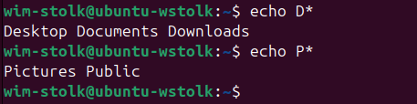

Think of the first example, D*, as "match all filenames in the current directory that begin with a capital d character and have zero or more of any other character after the D".

8.2.3 Step 3
The asterisk * can be used anywhere in the string. The following command will display all the files in your current directory that end in the letter s:
echo *s
Your output should be similar to the following:
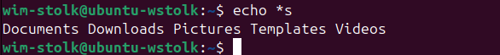

8.2.4 Step 4
Notice that the asterisk can also appear multiple times or in the middle of several characters:
echo D*n*s
Your output should be similar to the following:
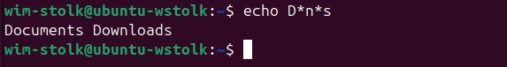

The next glob metacharacter that we will examine is the question mark ?. The question mark matches exactly one character. This single character can be any possible character.
Like the asterisk, it can be used anywhere in a string and can appear multiple times.

8.2.5 Step 5
Since each question mark matches one unknown character, typing six of them will match six-character filenames. Type the following to display the filenames that are exactly six characters long:
echo ??????
Your output should be similar to the following:
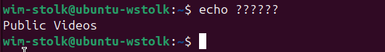
Important
Each ? character must match exactly one character in a filename-no more and no less than one character.

8.2.6 Step 6
Using the question mark with other characters will limit the matches. Type the following to display the file names that start with the letter D and are exactly nine characters long:
echo D????????
Your output should be similar to the following:
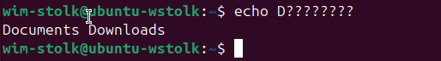

8.2.7 Step 7
Wildcards or glob characters can be combined together. The following command will display file names that are at least six characters long and end in the letter s.
echo ?????*s
Your output should be similar to the following:
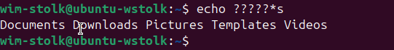
Think of the pattern ?????*s to mean "match filenames that begin with any five characters, then have zero or more of any characters and then end with an s character".

8.2.8 Step 8
The next glob is similar to the question mark glob to specify one character.
This glob uses a pair of square brackets [ ] to specify which one character will be allowed. The allowed characters can be specified as a range, a list, or by what is known as a character class.
The allowed characters can also be negated with an exclamation point !.
In the first example, the first character of the file name can be either a D or a P. In the second example, the first character can be any character except a D or P:
echo [DP]*
echo [!DP]*
Your output should be similar to the following:
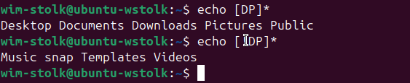

8.2.9 Step 9
In these next examples, a range of characters will be specified. In the first example, the first character of the file name can be any character starting at D and ending at P. In the second example, this range of characters is negated, meaning any single character will match as long as it is not between the letters D and P:
echo [D-P]*
echo [!D-P]*
Your output should be similar to the following:
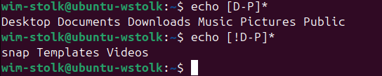
You may be asking yourself "who decides what letters come between D and P"? In this case, the answer is fairly obvious (E, F, G, H, I, J, K, L, M, N and O), but what if the range was [1-A]?
The ASCII text table is used to determine the range of characters. You can view this table by searching for it on the Internet or typing the following command: ascii
So, what characters does the glob [1-A] match? According to the ASCII text table: 1, 2, 3, 4, 5, 6, 7, 8, 9, :, ;, <, =, >, ?, @ and A.

8.3 Copying, Moving and Renaming Files and Directories
In this task, you will copy, move, and remove files and directories.

8.3.1 Step 1
Make a copy of the /etc/hosts file and place it in the current directory. Then, list the contents of the current directory before and after the copy:
ls
cp /etc/hosts hosts
ls
Your output should be similar to the following:
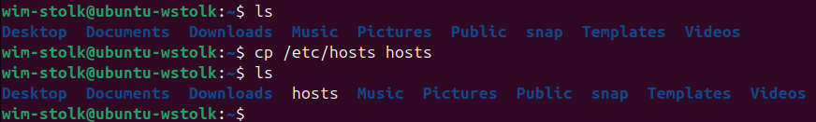
Notice how the second ls command displays a copy of the hosts file.

8.3.2 Step 2
Next, you will remove the file, then copy it again, but have the system tell you what is being done. This can be achieved using the -v or --verbose option. Enter the following commands:
rm hosts
ls
cp –v /etc/hosts hosts
ls
Note that the rm command is used to delete a file. More information on this command will be provided later in this lab.
Your output should be similar to the following:
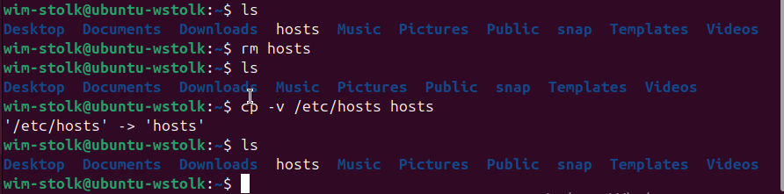

Note that the -v switch displays the source and target when the cp command is executed:
Source
`/etc/hosts'-> `hosts'
Target
`/etc/hosts'-> `hosts'

8.3.3 Step 3
Enter the following commands to copy the /etc/hosts file, using the period . character to indicate the current directory as the target:
rm hosts
ls
cp –v /etc/hosts .
ls
Your output should be similar to the following:
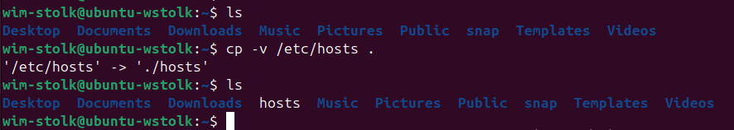
The period . character is a handy way to say "the current directory". It can be used with all Linux commands, not just the cp command.

8.3.4 Step 4
Enter the following commands to copy from the source directory and preserve file attributes by using the -p option:
rm hosts
ls
cd /etc
ls -l hosts
cp –p hosts /home/sysadmin
cd
ls –l hosts
Your output should be similar to the following:
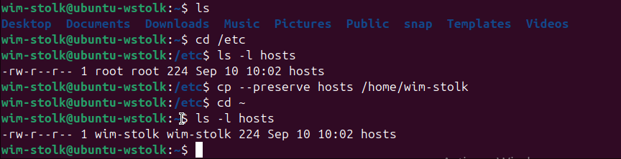

Notice that the date and permission modes were preserved. Note that the timestamp in the output above is the same for both the original and the copy (Jan 22 15:18) in the example provided above. Your output may vary.

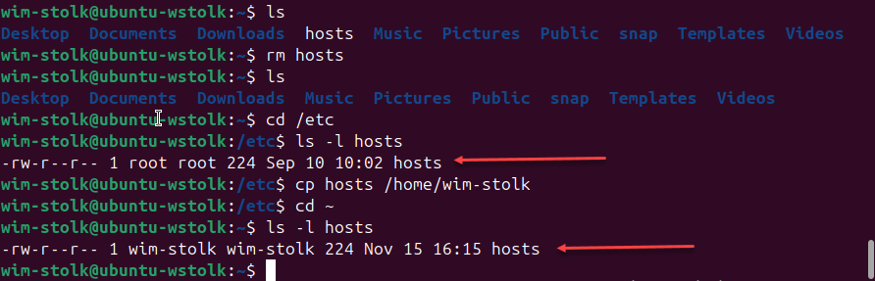

8.3.5 Step 5
Type the following commands to copy using a different target name:
rm hosts
cp -p /etc/hosts ~
cp hosts newname
ls –l hosts newname
rm hosts newname

The first copy with the -p option preserved the original timestamp. Recall that the tilde ~ represents your home directory (/home/sysadmin).
The second copy specified a different filename (newname) as the target. Because it was issued without the -p option, the system used the current date and time for the target; thus, it did not preserve the original timestamp found in the source file /etc/hosts.
Finally, note that you can remove more than one file at a time as shown in the last rm command.

8.3.6 Step 6
To copy all files in a directory, use the -R option. For this task, we will copy the /etc/udev directory into a new directory and display the contents that were copied there. Naturally, the directory must be created before files can be added to it. In this example we will use the default settings for mkdir to create the “Myetc” directory. Options are available for the mkdir command to set security, permissions and other attributes of a new directory. Once the directory has been copied, the ls command is used to list the contents of the directory with both the long and recursive options.
mkdir Myetc
cp –R /etc/udev Myetc
ls –l Myetc
ls –lR Myetc
sysadmin@localhost:~$ mkdir Myetc
sysadmin@localhost:~$ cp -R /etc/udev Myetc
sysadmin@localhost:~$ ls -l Myetc
total 0
drwxr-xr-x 1 sysadmin sysadmin 32 Jan 22 16:35 udev
sysadmin@localhost:~$ ls -lR Myetc
Myetc:
total 0
drwxr-xr-x 1 sysadmin sysadmin 32 Jan 22 16:35 udev

Myetc/udev:
total 4
drwxr-xr-x 1 sysadmin sysadmin 56 Jan 22 16:35 rules.d
-rw-r--r-- 1 sysadmin sysadmin 218 Jan 22 16:35 udev.conf

Myetc/udev/rules.d:
total 8
-rw-r--r-- 1 sysadmin sysadmin 306 Jan 22 16:35 70-persistent-cd.rules
-rw-r--r-- 1 sysadmin sysadmin 1157 Jan 22 16:35 README
sysadmin@localhost:~$

8.3.7 Step 7
To remove a directory, use the -r option to the rm command:
ls
rm -r Myetc
ls
Your output should be similar to the following:
sysadmin@localhost:~$ ls
Desktop Downloads Myetc Public Videos
Documents Music Pictures Templates
sysadmin@localhost:~$ rm -r Myetc
sysadmin@localhost:~$ ls
Desktop Documents Downloads Music Pictures Public Templates Videos
sysadmin@localhost:~$
Note that the rmdir command can also be used to delete directories, but only if the directory is empty (if it contains no files).
Also note the -r option. This option removes directories and their contents recursively.

8.3.8 Step 8
Moving a file is analogous to a "cut and paste". The file is “cut” (removed) from the original location and “pasted” to the specified destination. Move a file in the local directory by executing the following commands:
touch premove
ls
mv premove postmove
ls
rm postmove
Linux Command | Description
touch premove | Creates an empty file called premove
mv premove postmove | This command “cuts” the premove file and “pastes” it to a file called postmove
rm postmove | Removes postmove file
Your output should be similar to the following:
sysadmin@localhost:~$ touch premove
sysadmin@localhost:~$ ls
Desktop Downloads Pictures Templates premove
Documents Music Public Videos
sysadmin@localhost:~$ mv premove postmove
sysadmin@localhost:~$ ls
Desktop Downloads Pictures Templates postmove
Documents Music Public Videos
sysadmin@localhost:~$
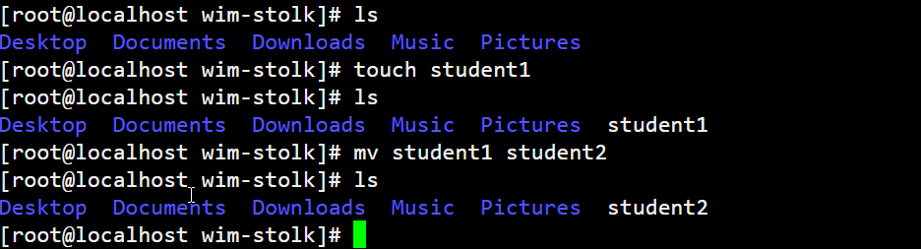

Extra opdracht:
Opdracht 1.
Maak eerst een snapshot!!!!!!!!!
Verwijderd alle directories en bestanden in de root (/)
Noteer de gevolgen!

Opdracht 2
Zoek een commando om een bestandsnaam te wijzigen. (Het mv commando mag je niet gebruiken)

